University Of Engineering and Technology, Lahore
Computer Engineering Department

Course Name: Programming Fundamentals | Course Code: CMPE-112L
Assignment Type:Lab Tasks | Dated: 25-05-2026
Semester: 1st | Session: Spring
Lab/Project/Assignment #: 12 | CLOs to be covered: CLO 2
Lab Title: Lambda Functions | Teacher Name: Hafiz Muhammad Mubashar
Lab Evaluation:

CLO1 | Apply appropriate programming techniques to create executable programs to solve well defined problems
 | Level1 | Level2 | Level3 | Level4 | Level5 | Level6
(5)
Total |  |  |  |  |  | /5
Rubrics for Current Lab Evaluation
Scale | Marks | Level | Rubric
Excellent | 5 | L1 | Submitted all lab tasks, BONUS task, have good understanding.
Very Good | 4 | L2 | Submitted the lab tasks but have good understanding
Good | 3 | L3 | Submitted the lab tasks but have weak understanding.
Basic | 2 | L4 | Submitted the lab tasks but have no understanding.
Barely Acceptable | 1 | L5 | Submitted only one lab task.
Not Acceptable | 0 | L6 | Did not attempt
LAB No 12
Lab Goals/Objectives:
To learn advanced applications of lambda functions and practice anonymous functions with different Python programs.
Equipment Required:
Computer or Laptop, Python 3.x, PyCharm or VS Code.
Theory:
Lambda functions are anonymous functions used for short operations. They can be combined with map(), filter(), sorting, and conditional expressions to write simple and efficient programs.

Lab Work:
Task 1: Find the square of a number using a lambda function.
Result:
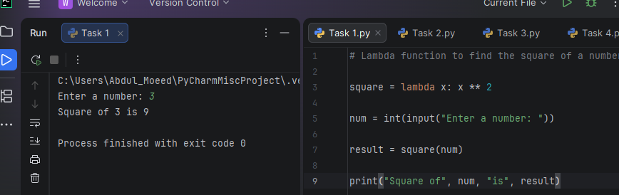

Task 2: Find the greater of two numbers using a lambda function.
Result:
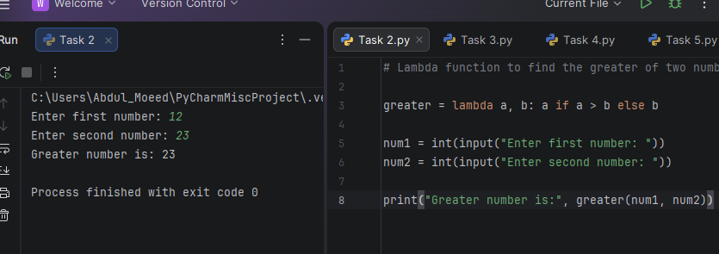

Task 3: Double list elements using lambda with map().
Result:

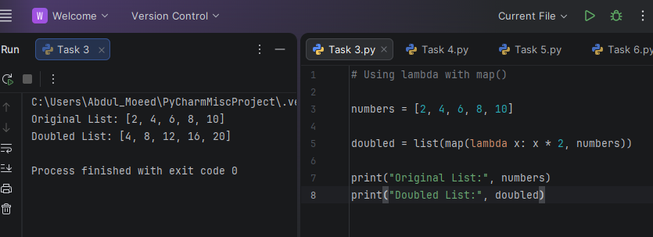

Task 4: Filter even numbers using lambda with filter().
Result:
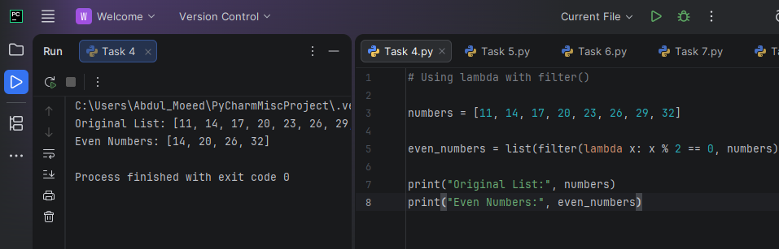

Task 5: Calculate simple interest using a lambda function.
Result:
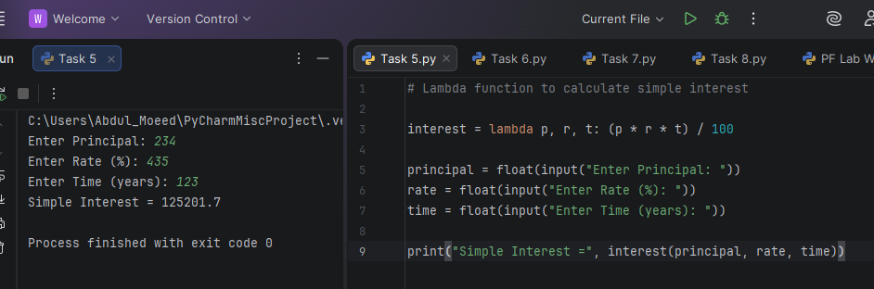

Task 6: Sort student records using lambda.
Result:
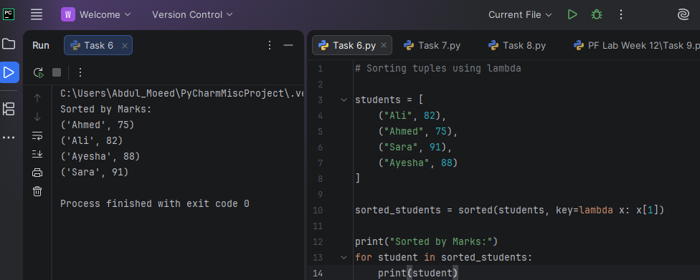

Task 7: Check whether a number is even or odd using lambda.
Result:
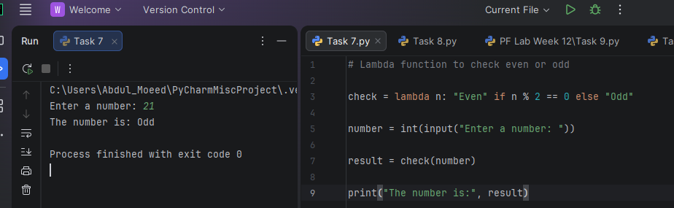

Task 8: Display a global variable in multiple functions.
Result:
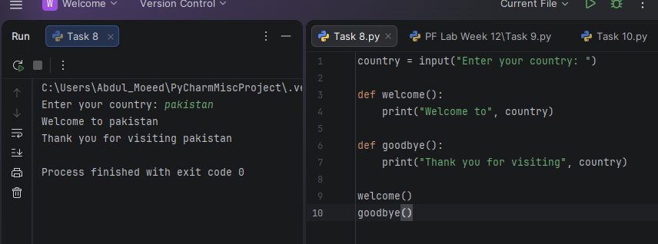

Conclusion:
The lab improved understanding of lambda functions and their use with different Python programming techniques.

